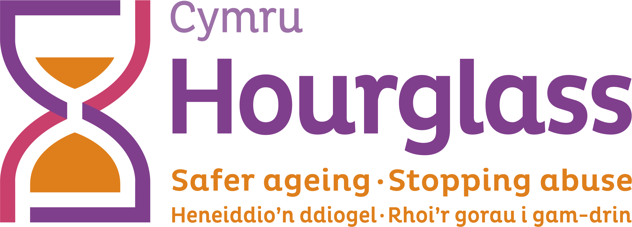
Job Description

Job title: | Community Response Assistant (Wales)
Location: | Home-based - able to travel across Wales occasionally
Duration: | Three years
Salary: | £19,425.00 per annum
Hours of work: | 35 hours Mon to Fri. Some meetings may be during evenings or at weekends
Reports to: | Community Response Coordinator (Wales)
Responsible for: | Volunteers
Job description last reviewed: | September 2023

- CONTEXT AND PURPOSE OF ROLE:

  - Hourglass is the only UK-wide charity, dedicated to calling time on the harm, abuse and exploitation of older people. We support older people experiencing (or at risk of) harm, abuse or exploitation, and work towards safer ageing and a fairer society for all older people.
  - The Community Response Assistant will play a key role in expanding our community response approach to supporting older people throughout Wales. The role presents a unique opportunity to deliver a responsive and person-centred approach to tackling and preventing the financial/economic abuse of older people. The postholder will work closely with staff, volunteers and local communities to develop our local, regional and national operations.

- MAJOR DUTIES AND RESPONSIBILITIES:

  - Community engagement activities
To carry out a range of activities to:
- raise awareness of the financial/economic abuse of older people and Hourglass Cymru support services
- facilitate engagement from older people, their families and a range of partner agencies
- develop a comprehensive understanding of local issues within the community

  - Community engagement activities will include:
- promotional activities in the local community, including developing links with local groups and agencies, preparing and distributing promotional materials, developing our social media presence, and hosting information stalls and attending relevant meetings and events
- keeping up to date with local issues and developments relating to older people, financial/economic abuse and other relevant areas
- ensuring all charity information and promotional materials are up to date, accessible and shared with relevant people, groups and agencies
- supporting with the development of a regular newsletter and online communications.

  - Supporting Hourglass volunteers:
To support the Community Response Coordinator with the recruitment, induction and ongoing support of a team of volunteers. This will include:
- supporting with volunteer recruitment including placing adverts, dealing with applications, references, DBS checks and training plans
- ensuring volunteers have access to relevant training and reference materials
- booking rooms/venues for training events, and dealing with training-related requirements and administration
- coordinating dates for training events and support meetings
- regular communication with volunteers, including check-ins, updates and support and guidance.

  - Supporting the charity’s fundraising functions:
To support the team with our fundraising objectives in Wales, including:
- identifying funding opportunities and building links with relevant partners, individuals and agencies
- contributing to fundraising events, initiatives and opportunities
- supporting our fundraising team with the administration, logging and analysis of fundraising data
- promoting fundraising campaigns and developments through various mediums.
- building relationships with local community groups and corporates to fundraise and build a pipeline of opportunities.
- Updating the Donorfy fundraising platform in a timely and accurate manner with key information and opportunities.

  - Administrative functions:

  - To act as the first point of contact for Hourglass Cymru, including dealing with enquiries from older people, their family/carers, volunteers, and a range of groups and agencies.

  - Updating charity databases and records, including our database for logging Helpline and other records (Customer Relationship Management system) and our fundraising database.

  - Supporting with the ongoing development of our administrative, IT and data collection processes, including the roll-out and further development of new systems

  - Maintaining and updating financial records relating to charity expenses and income and coordinating with central services staff.

  - Supporting the team with general administrative requirements, including scheduling meetings, arranging travel, filing, booking venues and other ad hoc duties

4. GENERAL
4.1 The Community Response Assistant will also be expected to:

- travel throughout the local community, and occasionally other parts of Wales, to meet the requirements of the role
- work unsocial hours on occasions and be flexible with working pattern as and when required
- follow good practice and company policies relating to health and safety, risk assessment, safeguarding, data protection and confidentially
- regularly liaise with other Hourglass staff and volunteers throughout the UK
- deputise for other staff as required
- complete any other duties which may be required, commensurate with the level of this post

PERSON SPECIFICATION:

ESSENTIAL CRITERIA:

- Excellent interpersonal skills and an ability to liaise and communicate effectively (both orally and in writing) with a range of people and agencies.
- Experience of supporting volunteers and/or service users in a community support/engagement context.
- Good understanding of social media and/or other promotional processes.
- Proven administrative experience, with a good understanding of spreadsheets, databases, email and other packages/processes.
- Strong organisational skills, and an ability to manage own workload, prioritise tasks, meet deadlines, and respond to emerging issues.
- Excellent written and verbal communication skills.
- Self-motivated, requiring minimal supervision.
- Able to cope with challenging or emotional calls/situations; and ability to deal appropriately with sensitive issues, working within the organisation’s confidentiality and data protection requirements

DESIRABLE CRITERIA:

- Experience of financial record-keeping.
- The ability to answer verbal enquiries in English and Welsh as well as respond to correspondence in both languages.
- Experience of uploading website content and/or newsletter production.
- Understanding of issues affecting older people and/or adult protection.
- Experience of voluntary work and/or community development activities.
- Access to own vehicle.

